

**Design Report**

**Core X-Y 3D Printer**

**June 5th, 2025**

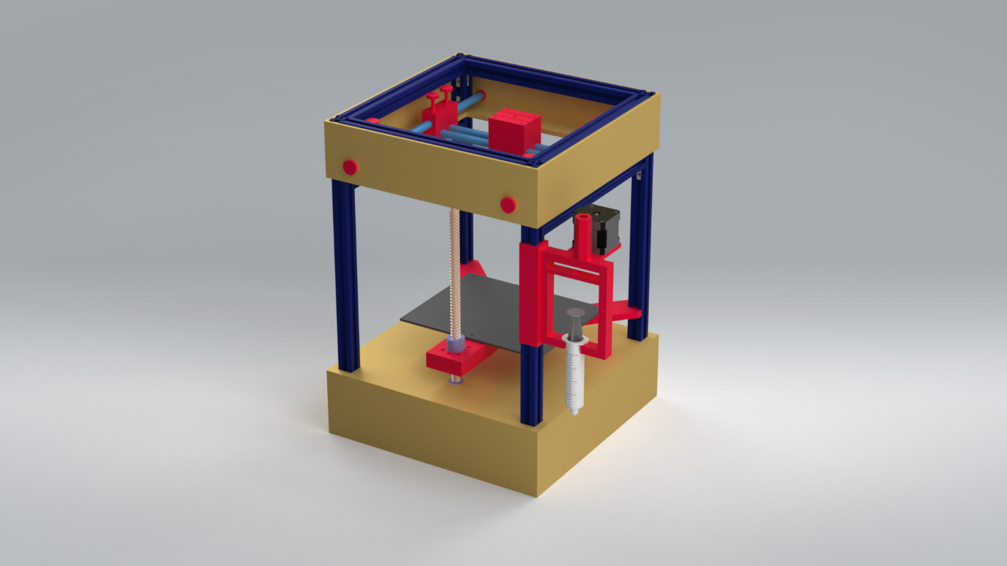

***Signed by lead team:***

|  |  |
| --- | --- |
| Director |  |
| Deputy Director |  |
| Chief Engineer |  |
| Deputy Chief Engineer |  |
| Chief of Production | Picture 2049273821, Picture |
| Chief of Automation and Control | Picture 1251755364, Picture |
|  |
|  |
|  |

# Table of Contents

Table of Contents 2

Introduction 4

Framework 6

Design 7

Introduction 7

Whole Frame 7

Frame Skeleton 8

Platform 9

Automation 10

Introduction 10

Design 10

Mechanism 12

Introduction 14

User Interface 17

Gantt Chart 18

EDI Report 19

Sustainability Report 21

Material Selection and Environmental *Impact* 21

Manufacturing and Production 21

End of Life Recyclability 21

Financial Report 23

Risk Assessment Form 28

Assessment of Status of Project 31

Bibliography 33

Appendix 34

Extrusion mechanism 34

Z-axis mechanism 36

X-Y Mechanism 41

Initial Code 44

# Introduction

The purpose of this report is to present our final concept, along with the design process and solutions we developed to address the challenge of effectively and accurately printing ceramic slurry using a custom-built mechanism. CeraTech’s objective is to engineer a 3D printing system capable of handling ceramic suspensions with varying rheological properties. To meet this goal, the team placed strong emphasis on developing a solution that is not only adaptable to different material behaviours but also economically viable and environmentally responsible. As can be seen from the schematic in Figure. 1, we chose to have a sturdy, box shaped 3D printer, with an extrusion mechanism on the side, an X-Y mechanism at the top, and a moving Z axis throughout centre of the machine.

Figure 1: full assembly of the CAD for the 3D printer

During the test phase, CeraTech experienced several key successes. Many of our prototype’s electronic components were highly accessible thanks to shared Arduino kits and resources from the department of Materials, which significantly accelerated development and cut costs. During assembly, most of our efforts were used on optimising the extrusion system and the X-Y mechanism, to ensure an even flow of slurry was printed, and the X-Y mechanism moved smoothly enough to allow this. Nonetheless, some challenges were identified; the greatest issue has been in difficulties with writing the code for the movement of the motors, which, if not fixed, will lead to a static and therefore useless 3D printer. Another notable issue involved the slurry container, which had been designed and then 3D printed, but proved to be too bulky and heavy in practice. This was then replaced with a syringe and a syringe holder. Additionally, the syringe and screw mechanism, initially 3D printed, presented problems due to heat generated by the motors. This heat risked deforming the printed parts, potentially leading to leaks or mechanical failure. In response, we did research into the melting point of the PLA used for 3D printing and the maximum heat that the motors reached. Our research led us to the conclusion that the PLA could withstand up to 60°C, whilst the motor only reached 50°C, so it was safe to use PLA to hold the motors. As a preventative measure, an aluminium heat dissipator was placed between the motors and the PLA. Furthermore, to improve stability during operation, we have reinforced the moving platform by adding more support rods. These updates were aimed at ensuring long-term durability and operational stability as we progress with development.

Throughout the development of our machine, we have carefully considered the risk of exceeding the £200 budget for components, as well as potential inaccuracies in the printer’s precision. Our design aims to minimise the number of moving parts to enhance reliability, stability, and cost-effectiveness. This design report will consider the automation, the movement and extrusion mechanism, and the main framework to give a comprehensive picture of the 3D printer. We will also be going into detail about our sustainability considerations, risk considerations, and equality dimensions.

This report reflects our iterative design journey and outlines how CeraTech’s final concept balances functionality, adaptability, and responsible engineering.

# Picture 675008581, PicturePicture 84682703, PicturePicture 398041974, PictureFramework

Members involved:

**Marifer Rodriguez Gomez (EDI Officer)** – I oversaw the assembly of the machine, including its construction and ensuring pieces were being printed. If pieces did not fit, or poorly fit the machine, I would readjust the CAD or help provide measurements for the readjustment of the CAD so that new, properly fitting parts could be made. I created and helped assemble many of the pieces for the CAD of the mainframe, as well as making a good amount of the technical drawings for the mainframe. I was also in charge of the assembly and maintenance of the CAD and ensured that it was always accurate and up to date, so that all pieces printed or cut from it would fit the machine properly. I have also helped by providing organisational tools for the group, as well as ensuring there is a focus and structure to every meeting by giving a brief rundown on what needs done every meeting and who needs to do it and by supervising each subgroup and providing support when it is needed.

**Alina Huber** **(Chief of Sustainability)** - I assisted with the physical assembly of the system, helping ensure components were correctly installed. I also conducted research into various material options, focusing on their mechanical properties and environmental impact to support sustainable design choices. In addition to my technical contributions, I took a leadership role in writing and coordinating many of the project documents. I largely helped in composing the final design report, ensuring that information from the initial concept design report was accurately updated and reflected. I also carefully documented key design decisions and their technical justifications to present a clear and comprehensive overview of the project. Throughout the process, I encouraged team members to continue developing their individual sections, helping to ensure consistency and clarity across the entire report. I played a key role in writing the letter to our “customers,” ensuring it reflected our progress and upheld our commitments. I also took charge of redoing our entire Gantt chart, restructuring and splitting tasks into clearer sections to improve both the chart’s clarity and its alignment with the design report.

**Samiya Ibrahim (Chief Financial Officer) -** I kept track of the company budget and placed orders for parts. I created both an official and unofficial excel spending sheet. Subgroups could request items on the unofficial sheet, and actual expenditures were listed on the official spending sheet to remain organised. Co-ordinated between the different subgroups to figure out whether requested items were compatible with our design. Additionally, I came up with the idea of minutes to help track decisions and follow up on tasks- made sure minutes were update them after each meeting. Furthermore, I helped with CAD assembly for the extrusion system and completed drawings for the gear within the extrusion system. Official expenditure sheets were made, tabularising data and justifying costs where necessary. Assisted in the physical assembly of the printer.

## Design

### Introduction

The 3D printer system chosen was the core X-Y system. This required a strong, cuboid frame with an open top to fit the moving mechanism. Furthermore, the frame needed to hold the electronic components safely below the printing plate, so a platform was made. The frame also had to be stable enough so that external vibrations did not affect the precision of the printing, and so that the 3D printer could stand solidly and without threat of collapsing.

### Whole Frame

The initial design for the frame was a cuboid with aluminium beams, a wooden base, and acrylic sides. The dimensions of the frame were initially 500mm x 250mm x 250mm. Once these dimensions were seen on the prototype version of the 3D printer, it was decided that the frame needed to be made smaller, to avoid having empty space in the machine, or a machine that was too bulky. It was decided that there should be two boxes, one at the top and one at the bottom, as can be seen from Figure 2. The top box was there to hold up the X-Y mechanism. As can be seen, the four holes in the sides of the top box are to hold the long rods for the X-Y mechanism. The bottom box was there to hide the electronics and most of the wiring, and the motor for the Z axis. To hold up the bottom of the top frame and the top of the bottom frame, support rods were put in on two sides of the cuboid, as can be seen on Figure 3. The hole at the top of the bottom box was put there to tightly fit the shaft coupler connecting the motor for the Z axis to the lead screw for the Z movement.

Figure 22: CAD of final frame

To ensure stability in the boxes, and that they were secured properly, a variation on box joints was made to attach each of the sides to each other and their base/top. The materials chosen for the boxes were initially MDF for the bases and the top of the bottom box, and acrylic for all the sided. It was later decided that MDF should be used for all the parts for the boxes, as can be seen from Figure 2. MDF of thickness 4mm was used for the sides of the box, whilst MDF of thickness 6mm was used for the base top and top base. The base was made up of 2 6mm MDF sheets glued together. The height of the machine was adjusted as the designs for each of the mechanisms were changed and ended up being 422mm. This was ideal as it provided the perfect height for the Z axis. The height accommodates for the motor, shaft coupler, and lead screw and the X-Y mechanism, and ensures that the top of the printing plate will be able to reach the nozzle attached to the X-Y mechanism.

### Frame Skeleton

Aluminium was selected for the frame due to its high tensile strength, lightweight properties, and excellent machinability. These properties also align with the structural requirements of our brief. This proved to be useful as we had to resize the beams several times when we decided to shrink the machine. The aluminium beams used were 20mm x 20mm aluminium profile struts. These were provided to us for free, which helped to cut costs. These beams were then cut to heights of 240mm and 422mm to give a frame of dimensions **240 mm × 240 mm × 422 mm**. The final design of the frame with adjusted heights can be seen in Figure 3.

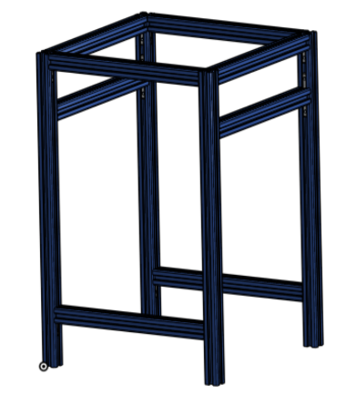

Figure 3 : CAD of final aluminium frame

Figure 33: CAD of final aluminium frame, with L-shaped joiners connecting the beams

To connect the horizontal beams with the vertical ones, L-shaped joiners were bought. Options such as 3D printed connectors were considered before settling on L-shaped joiners. However, these were chosen against as it was felt they would not provide sufficient support for the frame, and this was a place where structure and stability were of the utmost importance. For these reasons, metal L-shaped joiners were used to provide the most stability possible. How these connect can be seen in Figure 4. These components serve to reinforce the connections at critical junctions, minimising flexing and vibration during operation. By creating rigid, right-angled connections, the L-bars significantly improved the robustness of the frame, ensuring consistent alignment and precision throughout the printing process, especially under the dynamic loads imposed by the motion of the Core X-Y system.

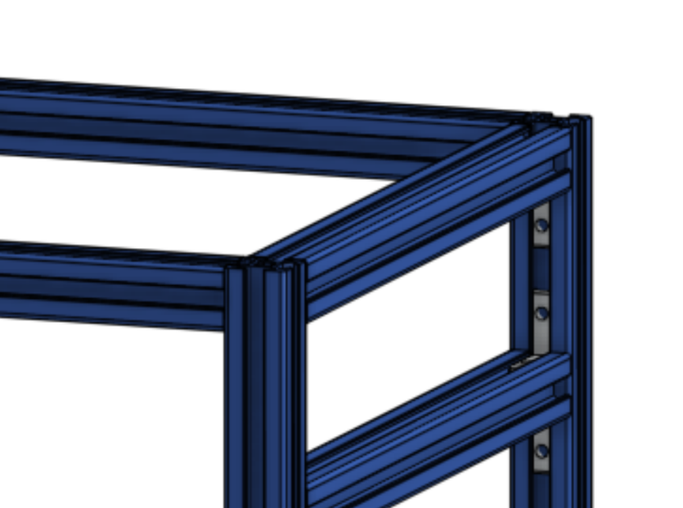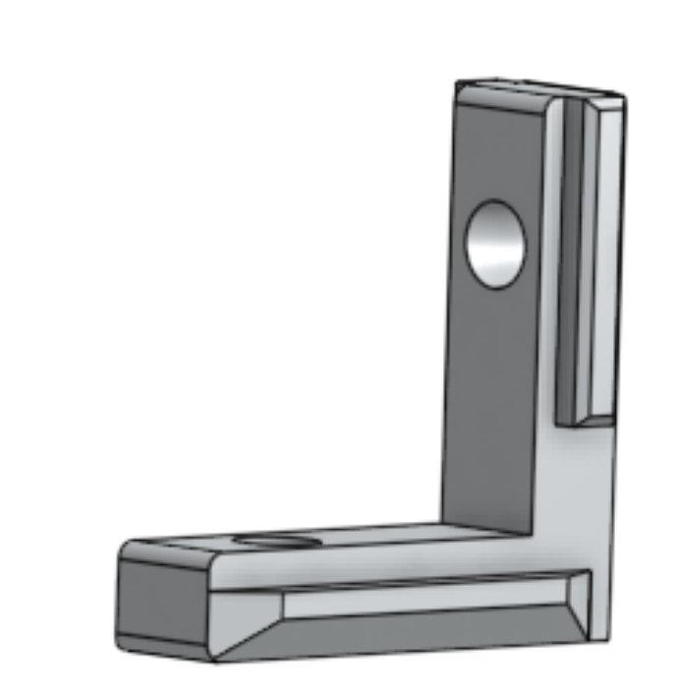

Figure 4 4: CAD of how the L-shaped joiners connect to the mainframe.

### Platform

The printing plate, which can be seen in Figure 5, was chosen to be aluminium due to its thin oxide layer’s chemical inertness with most liquids. Aluminium is also highly scratch-resistant which is a useful property in case we need to scrape the final product off the platform. It will be mounted on a motorised Z-axis assembly. As can be seen, the printing plate will be attached to a 3D printed base, which connects to two beams and the lead screw. It will be attached to the 3D printed base using magnets, which will allow for easy removal and replacement of the plate from the base. For the dimensions of the plate, a **200mm x 160mm** plate was cut from a sheet of aluminium. This sizing was chosen as it is slightly bigger than the range of motion of the X-Y system and is smaller than the size of the 3D printer, so it will fit comfortably while not sacrificing printing area.

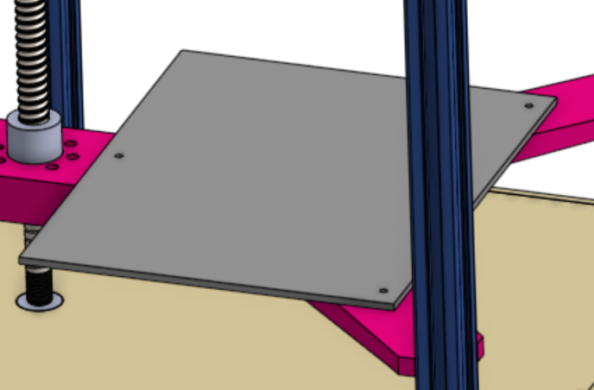

Figure 55: Zoomed in image of 3D printer, with focus on the printing plate

# Picture 356506622, PicturePicture 1251755364, PictureAutomation

Members involved

**Tolly (Chief of automation and control)** - I researched methods to move the motors and made decisions on what items to buy. I was responsible for wiring and testing the stepper motors, configuring the CNC shield with the DRV8825 drivers, and writing Arduino test code to verify motor functionality. I led troubleshooting when motors were beeping and not turning. Led efforts to wire and code in order to turn the motors and overcame many issues in late arrival of critical items that were needed before testing could begin. Prior to this I worked on the Frame sub

**Dylan (Director)** – As part of the automation team, I worked with Tolly to troubleshoot issues with the electronics to try to get the motors to move and currently in the process of developing code on Marlin to enable the motors to move the printer nozzle in all 3 spatial dimensions. In addition to this I researched the best stepper motor driver to use for the printer and the DRV8825 driver was the outright best option. During this time, I was also working with Alina to develop the framework for this report and also worked with Samiya on placing company orders.

## Introduction

The aim of this sub team was to connect the motors and electronics to the Arduino controller and use the Marlin framework to move the motors to move the mechanical parts of our design accordingly. Further work should be done on G-code conversion and on a graphical user interface to streamline the user experience instead of a command-line interface.

## Design

We chose to use the Arduino Mega 2560 that was provided to us in the base kit. We had four motors to power, two for the X-Y system, one for the Z system and one for the extrusion system. We chose to use the CNC shield V3, which would allow simple wiring for our DMV8825 stepper motor drivers and compatibility with the Arduino Mega board. We chose to use the DMV8825 instead of A4988 stepper motor drivers as it offers a higher current and voltage range, as well as a smaller micro stepping size of 1/32 instead of 1/16 for the A4988, allowing for more precise movement.

For the automation and control system of the 3D printer, we chose to use an Arduino Mega 2560 microcontroller paired with a CNC shield, which provided a cost-effective platform for motion control. The CNC shield allowed for straightforward wiring with stepper motor drivers (specifically DRV8825s), and its pin layout matched standard GRBL-compatible firmware, simplifying development. This choice enabled flexible control over the X, Y, and Z axes as well as the extrusion mechanism, and allowed for easy replacement or reconfiguration of individual components if any issues arose during testing.

We selected NEMA 17 stepper motors for their balance of torque, precision, and affordability, and configured them for 1/32 micro-stepping, as aforementioned, to improve smoothness and resolution of movement. The DRV8825 drivers were set with appropriate current limits and micro-stepping modes to match the requirements of our Core X-Y layout, which demands synchronised movement of two motors for planar control. This necessitated careful consideration of motor direction, pulse timing, and step coordination, all of which were implemented through custom Arduino routines for initial testing.

G-code parsing and execution were planned as the backbone of the automated control system, allowing the printer to follow pre-generated toolpaths. While we considered using GRBL firmware for G-code interpretation, we ultimately began with custom Arduino code to better understand the system dynamics and retain flexibility during early development. There were plans to use an adapted version of the Marlin software, but delays in getting the motors to work have made this difficult. The wiring had to be tested and functional before work on the software to run the motors could get underway. This led us to use Universal G-code Sender, a simpler app allowing fine hardware control through a graphical interface with a G-code command line, with the G-code generated by Prusa Slicer.

# Picture 1213390280, PicturePicture 2049273821, PicturePicture 137761542, PicturePicture 367224507, PicturePicture 1212807782, PictureMechanism

Picture 584785219, PictureMembers involved:

**Sean Foong (3D Printing Engineer)** - I redesigned our 3D printer’s extrusion mechanism, transitioning from the original screw-driven system to a plunge-based design. The previous mechanism resulted in substantial slurry waste due to a gap at the bottom of the extrusion cylinder, which misaligned with our sustainability objectives. The new plunge mechanism features a significantly simpler design and greatly reduces material waste. Following the decision to fix the plunge mechanism in place, rather than allow it to move along the Z-axis, I designed a compatible nozzle to be attached effectively with the component developed by the Z-axis subgroup. As part of the overall redesign, I also implemented several adjustments to account for inconsistencies in our 3D printing tolerances due to a faulty printer. In addition, I repurposed a previously created kinematic arm sketch into a lightweight syringe mount for integration with the mainframe. This solution was chosen for its mechanical simplicity and favourable weight distribution. With the extrusion mechanism completed ahead of schedule, I have since redirected my efforts toward supporting the development of other subsystems, including automation and X-Y coordinate control. The next phase will involve performance testing and targeted refinements to further enhance printing precision, stability, and overall efficiency.

**Llio Mutembo (Deputy Chief Engineer)** - I have been responsible for creating the parts list and production record for the printer; ensuring all components past and present are accounted for and aligned with our design requirements. This required a methodical approach to documentation, regular communication with the teams, and careful version control to avoid discrepancies. I also carried out research into cooling solutions to maintain consistent operating temperatures. Using thorough cost analysis along and spec analysis to predict operating temperatures concepts have been made but not yet implemented. Some of these include the use of concepts that have yet to be implemented. Additionally, I supported the extrusion system development by helping resolve minor issues, such as identifying the most effective adhesives compatible with PLA for secure, leak-free assembly.

**Asher Trueman (Chief Engineer, Laser Cutter) -** I began the project focusing on research for the movement mechanism, as well as the creation of the first Gantt chart. Since then, I have shifted my attention purely to the design and construction of the X-Y movement mechanism. Although the way the printer head moves via the pulley system is a standard 3D printer design, the structure and design of all components is original. I have designed this system throughout the project, refining specific components multiple times to perfect the mechanism. This has mostly been done through CAD, with all components of the X-Y system being 3D printed apart from the aluminium rods, timing belts and belt idlers. The print head has run into a few issues that required changing of the design: tolerance issues relating to the fit of the belt, clearance issues with the print bed, and uneven height with the rest of the system. In each instance, I changed the design and reprinted. The printer head also required careful communication with the extrusion team, as the tubing holding the ceramic filament and the print nozzle is housed on the print head. Additionally, the sliding rod connectors on either side of the mechanism ran into an issue where the pulley system applied too much force to the rods to which the belt idlers were attached. This required redesigning the component, including the development of a way the rods would not break under load. Ultimately, long rods were printed separately and glued into holes added to the connectors. Ensuring that the tolerances for the sliding parts (print head, rod connectors in one direction) were sufficiently smooth also required refining and oiling. As the laser cutting engineer, I have also been tasked with cutting the sides of the frame. As chief engineer, apart from the standard tasks I have also helped fix issues with the extruding mechanism. Ultimately, my main contributions have been designing, refining and building the X-Y movement mechanism.

**Kevin Han (Deputy Director)** – My contribution to the X-Y movement mechanism, in collaboration with Asher (Chief Engineer), involved researching and selecting the most suitable belt idlers for our design. I also worked on determining the most space-efficient positioning of the idlers to ensure smooth mechanical movement and minimise the risk of belt entanglement. Additionally, I researched and tested different types of lubrication for the printer head's movement along the rods. This led to the decision to use oil instead of grease, despite the potential mess, as grease tends to accumulate at the interface between the print head and the rods. Before conducting this research, I had to address the challenge of fitting the rods into the print head, as dimensional inconsistencies often occur during the 3D printing process. These efforts helped eliminate the jerky movement of the print head, which could otherwise affect the overall print quality. Furthermore, I assisted other subgroups with various tasks, including metal cutting for the rods and main frame, and assembling parts of the frame structure.

**Max Tan** **(Chief of Production)** – At the beginning of the project, I contributed to creating and assembling the part lists and production lists. As the project progressed, I shifted my focus to redesigning and finalizing the movement mechanism along the Z-axis. In the initial design, we employed a system that included ball bearings, gears, and a belt to drive the lead screw. However, this approach increased both the cost and the complexity of the system, leading to reliability concerns. To simplify the design and enhance reliability, I replaced the previous mechanism with a shaft coupler that directly connects the lead screw to the motor. This change significantly reduced uncertainty and streamlined the assembly process. Due to the limited space available on the CNC shield, only one motor could be allocated for the Z-axis. As a result, the kinematic arm supporting the print bed also had to be redesigned. I proposed a Y-shaped design: the tip of the "Y" is mounted into the aluminium beam and is allowed to move freely, while the bottom is attached to the ball screw. This configuration provides structural rigidity and reduces the number of additional components required, making the design more cost-effective and mechanically efficient. The next step is to conduct a final test of the system and adjust the weight distribution to ensure the print bed remains flat and stable during operation.

**Vanessa Zhang (3D Printing Engineer)** - I was involved in the redevelopment of the plunge-based extrusion mechanism for our 3D printer, along with Sean. My work included researching alternative design approaches, identifying necessary components, and refining the geometry of parts like the syringe holder and nozzle to prevent leaks and support smooth, consistent extrusion. I assisted Llio with maintaining and updating the parts list, keeping track of 3D-printed components and estimating the remaining printing material. I collaborated closely with Sean throughout the process and worked with the financial officer to ensure key components—such as the syringe tube—were ordered in time for assembly and testing.

## Introduction

The mechanism subsystem of our 3D printer is responsible for the precise and coordinated movement of the extrusion head across the X, Y, and Z axes, as well as for controlling the extrusion of ceramic material. It receives coordinate commands from the control system and translates them into physical motion across the build volume.

Each part has been individually designed to maximise motion precision and mechanical stability:

* The X and Y axes use a belt-driven linear rail system to achieve high-speed, accurate horizontal positioning of the print head.
* The Z-axis employs a stepper motor, lead screw, and a 3D-printed holding arm to move the print bed vertically with precision and control.
* The extrusion mechanism uses a gear-and-screw drive attached to a syringe plunger, allowing for regulated, consistent flow of the ceramic suspension through the nozzle.

These three mechanisms work together to produce synchronised and repeatable movement, ensuring reliable print quality. Throughout the development process, all three primary motion systems underwent significant refinements. The extrusion system underwent major improvements following initial prototype testing, which revealed several key issues: concerns about leakage from the 3D-printed syringe, a gap that could lead to material waste, and the syringe being too large to securely mount on the main frame—raising concerns about the frame’s ability to support its weight.

To address these challenges, a custom-designed syringe holder, as shown in figure 6, was created to provide stable support, and a custom gear system was developed and refined. This system uses two specifically shaped interlocking gears: when the smaller gear, connected to the motor, turns, it drives the larger gear, which in turn pushes the syringe plunger downward smoothly and reliably to extrude the ceramic slurry. However, the system was designed to only apply downward force on the plunger, with no mechanism to retract it. To overcome this limitation, we adopted a practical solution: instead of resetting the plunger or replacing the entire syringe—which would be inefficient—we unscrewed

and refilled the same syringe once emptied. This allowed for continued use without wasting materials or disrupting the setup. Further difficulties arose in determining how to securely attach the syringe holder to the main frame. To avoid damaging the frame or causing structural instability, we first 3D printed a small test segment of the holder to experiment with fit and tolerances. This allowed us to identify a geometry that provided a snug, reliable grip without compromising the frame. Once confident in the design, we printed the full-length version and reinforced the attachment with superglue, resulting in a stable and effective solution.

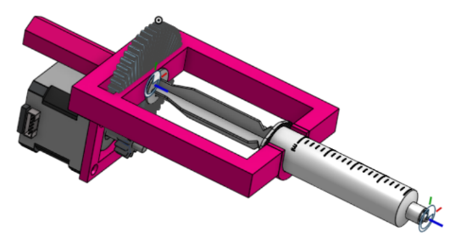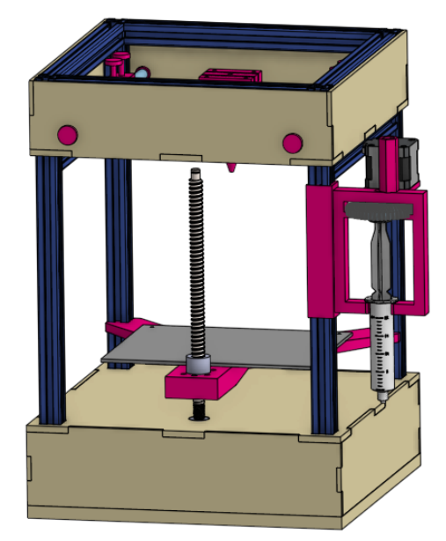

Figure 6 6: CAD of where the syringe holder is positioned on the main frame

For the X and Y axes, careful adjustments were made to the size and layout of the moving parts, especially the print head carriage, to ensure reliable contact with the kinematic bed and to minimise deflection during movement. From the initial prototype stage, four iterations of the movement system were trialled before the final design was acceptable. Tolerance issues, design flaws and the aforementioned print head height were all significant factors during the refinement of the design. The final design features most components made of 3D printed material, with aluminium railings and timing wheels for smoother movement of the printer head. Figure 7 illustrates the connection between the movement system and the main printer frame.

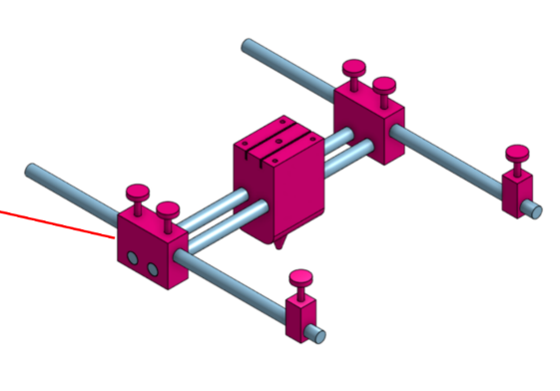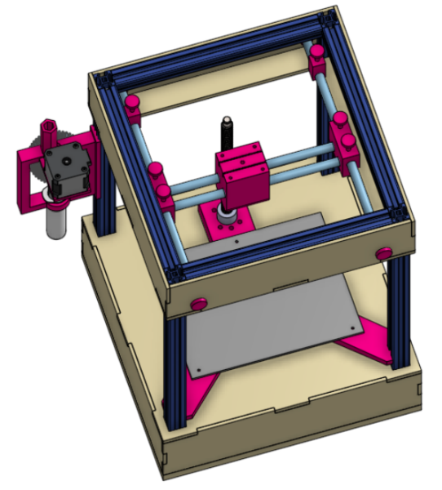

Figure 7: CAD of where the X-Y Movement Mechanism meets the Frame

Figure 7: CAD of where the X-Y Movement Mechanism meets the Frame

The original Z-axis concept, which used belts and gears to couple the motor to the lead screw, was replaced after cost analysis and reliability concerns. A shaft coupler was ultimately chosen for its simplicity and robustness.

In addition to enhancing structural rigidity, the design has been streamlined from three kinematic mounts to a single Y-axis mount, with each arm tip connected to an aluminium bracket, as shown in Figure 8. The Y-axis mount was carefully tested to adjust the weight distribution to ensure most of the weight lies closer to the ball bearing. This improved vertical rigidity and endured the turning torque, which helped eliminate mechanical backlash during operation.

Figure 8: 7 CAD of where the z-axis system is positioned on the main frame

Figure 7: CAD of where the X-Y Movement Mechanism meets the Frame

Lastly, to ensure the kinematic bed can be attached and taken off easily from the mounting arm, a magnetic connection is designed and inspired by pre-existing core X-Y printer $.^{[2]}$

These improvements collectively enhanced the overall performance of the printer and ensured seamless integration of the motion subsystem with the extrusion and control systems.

# User Interface

To import and execute the G-code on the 3D printer—powered by an Arduino board running GRBL firmware—the Universal G-code Sender (UGS) application was used. UGS provides an easy and efficient interface for sending commands directly to the Arduino running the GRBL package. Its selection was based on its ability to offer real-time machine control, manual command entry, and dependable execution of complete G-code files. UGS is particularly well-suited for non-standard 3D printing applications, such as ceramic slurry extrusion, due to its flexibility and the level of direct hardware control it offers for testing and calibration purposes.

Once the Arduino is connected to a computer via USB, UGS enables the user to execute almost any standard G-code commands, such as axis homing and manual movement. This process effectively bridges the gap between the slicing software and the printer hardware by offering direct access to low-level control functionality.

G-code files are generated using PrusaSlicer, configured to match the specific characteristics of the printer, including print area dimensions, feed rates, and extrusion parameters. These files can then be imported into UGS, which allows the user to stream the G-code to the Arduino. The GRBL firmware interprets the commands and drives the printer's stepper motors and extrusion system, accordingly, effectively enabling the Arduino to serve as a command interpreter for the mechanical operations of the printer.

# Gantt Chart

# EDI Report

Throughout the entire process of conceptualising, designing, and constructing the 3D printer, it was important to ensure the core values of equality, diversity, and inclusion were upheld. This was done to create a workplace that was safe and comfortable, where everyone felt seen, heard, and appreciated.

In the initial design phase, issues were raised as a few quieter members felt their voices and opinions were not being heard. This was solved by having clear, intentional conversations about what decisions we were making, and ensuring everyone had a chance to speak and voice their ideas and opinions during the conversation. The use of forms was also implemented at this phase to ensure any future issues were anonymous and addressed quickly and effectively. This helped to ensure everyone voiced their true views without any restraints and helped to provide an honest view of how everyone was feeling. It also established strong communication within the group, which helped in dealing with issues going forward.

During the prototype phase, the main issues were the lack of organisation and structure to the meetings. As meetings were often started without any particular focus or goal in mind, a lot of time was wasted in each member trying to understand what they could work on during the meeting and often overlap occurred in work that was being done. This was an inefficient use of time and thus had to be addressed. To fix this, a shared document was made where notes were taken about what had been done during the meeting that week, and plans were written down of what was to be done the next week, with specifics noted. This helped to organise meetings and gave them a sense of purpose, which helped increase the group’s overall drive and clarity on what was happening and increased our time management.

The main issues that arose during the assembly phase were again a lack of organisation within the group. This issue began as the subgroups were not clearly defined at the start, and thus everyone was working on different things without any order or focus. This was fixed by refocusing everyone's efforts to their specific, assigned subgroups and roles within these subgroups, and making sure that everyone had something specific to be working on during each meeting. To achieve this, tasks were delegated carefully to individuals. At the start of each session, a chat was also initiated to ensure the meeting had structure and that progress was being made. As the deadline was closer, the group was experiencing more stress and anxiety. To alleviate this, a team bonding activity was organised in the park so that everyone could destress and refocus.

Going forward, care will be taken to ensure no time is wasted during meetings, and work will be purposely delegated to each member of the group that fits their abilities and strengths. This will help to improve our productivity and organisation as a group.

# Sustainability Report

Sustainability was a key consideration throughout the design process, with the goal of minimizing the product’s carbon footprint while maintaining performance, durability, and manufacturability. Design decisions were informed by the environmental impact of materials, the energy involved in production, and the product’s end-of-life outcomes.

### Material Selection and Environmental *Impact*

Aluminium was selected for both the framework and the printing plate due to its excellent strength-to-weight ratio, corrosion resistance, and long lifespan. Most importantly, aluminium is highly sustainable, it can be recycled indefinitely without loss of mechanical properties and with up to 95% less energy compared to producing primary aluminium. This reduces both the embodied carbon of the product and the demand for raw material extraction. Its durability also ensures a longer service life, reducing the frequency of replacements and further cutting resource use over time $.^{[1]}$

The base is made from two layers of 9mm MDF wood, which typically uses compressed and recycled wood fibres. This supports circular material use and reduces reliance on virgin wood sources. For the walls, a choice between acrylic and wood was considered. Acrylic offers durability and potential recyclability, while wood provides a biodegradable, renewable alternative when responsibly sourced.

### Manufacturing and Production

The plunging system integrates standard metal screws with 3D-printed components. 3D printing allows for efficient, on-demand production while significantly reducing material waste compared to traditional subtractive manufacturing methods. To enhance sustainability, the 3D-printed parts were primarily made using PLA, a bioplastic derived from renewable resources like corn starch. Although PLA is not widely recyclable through conventional municipal systems, it is industrially compostable and offers a lower environmental impact than petroleum-based plastics $.^{[3]}$

### End of Life Recyclability

The product has been designed with disassembly and material separation in mind, ensuring that its environmental impact is minimised at the end of its life cycle. Components can be easily detached without damaging adjoining parts, allowing for straightforward repair, reuse, or recycling.

Materials were carefully selected based on their recyclability and environmental impact. Aluminium parts are highly recyclable and can be repeatedly reprocessed without loss of quality. Wood components are biodegradable and, if untreated, can safely break down in natural environments or be repurposed. Standard metal fasteners and screws are also fully recyclable within existing waste management systems. By designing for disassembly and using recyclable or biodegradable materials, the product significantly reduces the likelihood of components ending up in landfill, supporting a circular economy and promoting sustainable product lifecycle management

# Financial Report

|  |  |  |  |  |  |  |  |  |
| --- | --- | --- | --- | --- | --- | --- | --- | --- |
| **Design Office** | | **Name of Item** | **Name of Supplier** | **Link for purchasing** | | **Number of items required** | **Cost per unit /£** | **Cost total/£** |
| Automation | | Anti Blacklash Ball screw CNC Parts | CNCMANS | <https://www.amazon.co.uk/gp/product/B09FXZ82KM/ref=ox_sc_act_title_1?smid=A1PK9C1KZR0JGY&th=1> | | 1 | 11.59 | 11.59 |
| Automation | | Stepper Motor Driver Module for 3D Printer | Amazon | <https://amzn.eu/d/b4GE9sL> | | 1 | 7.99 | 7.99 |
| Automation | | Drive Belt, 1080mm Length | RS PRO | <https://uk.rs-online.com/web/p/v-wedge-belts/2056726?gb=s> | | 1 | 8.14 | 8.14 |
| Automation | | Motor | Amazon | <https://amzn.eu/d/c5gn8P9> | | 5 | 6.66 | 33.29 |
| Automation | | Shaft coupler | Redrex | [https://www.amazon.co.uk/Redrex-Aluminium-Flexible-Couplings-Coupler/dp/B01M20UML7](https://www.amazon.co.uk/Redrex-Aluminum-Flexible-Couplings-Coupler/dp/B01M20UML7) | | 1 | 6.58 | £6.58 |
| Automation | | Saipor GT2 20 Teeth 5mm Bore Timing Pulley Aluminium Synchronous Wheel for 6mm Belt | Amazon | <https://amzn.eu/d/ddLB16z> | | 2 | 5.99 | 11.98 |
| Mechanism | | sourcing map Silicone Tubing, 2mm ID x 4mm OD 1.5m Rubber Tube | Amazon | <https://amzn.eu/d/degTSGl> | | 1 | 4.09 | 4.09 |
| Mechanism | | PVC Clear Vinyl Tubing | TA-VIGOR DIRECT | <https://www.amazon.co.uk/gp/product/B0CYQ565L6/ref=ox_sc_act_title_2?smid=A2BP2NPRP802AW&th=1> | | 1 | 5.09 | 5.09 |
| Printer Design | | Aluminium Rods,10mm x 300mm Round Solid Aluminium Rods (2PC) | Amazon | [iMeistekAluminium Rods,10mm x 300mm Round Solid Aluminium Rods bars for RC Model Cars,Gardening Decoration,Industry Machinery,DIY Crafts(2PCS) : Amazon.co.uk: Business, Industry & Science](https://www.amazon.co.uk/gp/product/B0CLXBF3D3/ref=ox_sc_act_title_2?smid=A11ZIIEJF0IV4J&th=1) | | 2 | 9.99 | 19.98 |
| Printer Design | | L-Shape 90 Degree Interior Inside Corner Connector Joint Bracket with Screws | Amazon | <https://amzn.eu/d/8ivwbWb> | | 1 | 11.99 | 11.99 |
| Printer Design | | 4.0mm 4mm/6mm/9mm MDF Premier (laser-grade) 300x200mm/600x300mm - 300x200mm | Hobarts | [4mm/6mm/9mm MDF Premier (laser-grade) 300x200mm/600x300mm](https://hobarts.com/products/4mm-6mm-9mm-mdf-premier-laser-grade-300x200-600x300?variant=55249832739196) | | 2 | 0.30 | 0.60 |
| Printer Design | | 6.0mm MDF Premier (laser-grade) - 300X300mm | Hobarts | [MDF Premier (laser-grade)](https://hobarts.com/products/mdf-premier-laser-grade?variant=53590190227836) | | 4 | 0.87 | 3.48 |
| Printer Design | | 10pcs/lot Steel Ball Bearings | Amazon | [10pcs/lot Steel Ball Bearings 10mm K800 M4 Threaded Rod End For Reprap Delta Kossel Magnetic Joints 3D Printer Parts distinctive : Amazon.co.uk: Business, Industry & Science](https://www.amazon.co.uk/Bearings-Threaded-Magnetic-Printer-distinctive/dp/B0BTNYRDYK/ref=sr_1_1?crid=2ZNGQ5SGLVKXH&dib=eyJ2IjoiMSJ9.bSFPUxX1uByrc29Nk2uptdpnImbO4HW9kuzLT5HRS80.zLT3d7dCgdMm2jZSTM7gU8zOXsT12kLB2qvuFPpPEco&dib_tag=se&keywords=Delta+KOSSEL+K800+steel+ball&qid=1746547026&sprefix=delta+kossel+k800+steel+ball%2Cspecialty-aps%2C62&sr=8-1) | | 1 | 15.36 | 15.36 |
| Printer Design | | JD Multi Metals - Aluminium Sheet Plate 1mm Thick - Various Sizes, Aluminium, 300mm x 300mm | Amazon | [JD Multi Metals - Aluminium Sheet Plate 1mm Thick - Various Sizes, Aluminium, 300mm x 300mm : Amazon.co.uk: Business, Industry & Science](https://www.amazon.co.uk/JD-Multi-Metals-Aluminium-Various/dp/B0765YQR2H/ref=sr_1_54?crid=1F7UPL6Q9982A&dib=eyJ2IjoiMSJ9.oX6pNp1DglWYIRedJ2_dnGDYzhtmiTCoWwENUrq-qkhpgtRkKdcEqbKzhGJbUxwvQIkqLOFc3gHmPO8AweNx6nl3UWalA1SME-BXEyzs0HfrxaB2xMmmwMUqJtxj73NqTwFHrEZJWR98YMr6yg00xBrZS4U83sbTjjQ2RY3CZyZ7Z4k5LBe-8x4kkhlresK5_F51OG0AASwBpmhFoeSZy7rbTOKqbIJ8IqML5C7luQV8OhUJwa7RgCg8UDWlddXrgID7kHsAU2AqluwkGGLQGpYgJt8RPFTS1nJnyTDxiycdJawmrIKpPdyjN9EUxr_zyEmu2LnVxRc5dOE7SbyxXJwKkhMnJcBeOJ45IkwoyNhRB5Wru8jmnsWUHarJi6LvzxhR_2YRcYIvXjUznsfWM4E4tm0146hC-tLwaEL8pnpo4nqCJNrSFNhOdsnSui8X.ef4o9dfwjhd9e23MX2986uiFWKU2u1Whsdh-T6U0va4&dib_tag=se&keywords=300x300+aluminium+plate&qid=1739047694&sprefix=%2Caps%2C54&sr=8-54&xpid=5zjDyt8HSjrB6) | | 1 | 10.99 | 10.99 |
| Printer Design | Pronto Direct Neodymium Countersunk Ring Magnets | Amazon | <https://amzn.eu/d/a7Wm8J5> | | 1 | 3.99 | 3.99 | |
| Printer Design | 2Pin DC 12V Small Cooling Fan With Wires | Amazon | <https://amzn.eu/d/c5gn8P9> | | 1 | 6.59 | 6.59 | |
| **Automation Expenditure:** | | | | | | | | £79. 57 |
| **Extrusion Expenditure:** | | | | | | | | £9.18 |
| **Printer Design Expenditure:** | | | | | | | | £72.98 |
| **Total Expenditure:** | | £161.73 | | | | | | |

One of the larger costs in creating our product has been the cost of our aluminium rods. Our company invested in expensive aluminium rods for our movement system as our structures had to be able to withstand the high-speed movement of the nozzle during printing, as well as prevent misalignment. The low environmental impact was also considered. Another significant expenditure was our motors, which were costly as we required high torque motors, one for the extrusion system and 3 for the movement. Dimensional accuracy was another factor we reflected upon. We currently do not require anything from the departmental store.

# Risk Assessment Form

|  |  |
| --- | --- |
| **Risk Assessment for:** | Operations and use of 3D printer |
| **Task:** | Print parts for assembly of printer |
| **Assessment ref. No.** |  |
| **Assessment undertaken by:** | Dylan Taylor (Director) |
| **Signed:** | Ink 2, Shape |
| **Date:** | 27th of May 2025 |
| **Assessment review date:** |  |

|  |  |  |  |  |  |
| --- | --- | --- | --- | --- | --- |
| **Hazard** | | | **Persons at Risk** | **Existing Controls** | **Action Needed** |
| Tripping over the machine’s cables | Anybody walking around the machine | Keep all cables within the machine chassis except the power cable, which would not be long enough to trip over. | Check if the person is hurt and a member of staff for help. | | |
| Finger getting stuck in the machine | Members of the team operating the machine | Designate machine operator specialists such as chief engineer and chief of production who know how to use the machine correctly. | Turn off the machine immediately and call a senior member of staff for assistance | | |
| Printing nozzle cutting/poking somebody | Members of the team operating the machine | Only keep the nozzle of the machine on when it’s time to print, otherwise it can remain off. | Seek first aid assistance from a member of staff immediately | | |
| Accidental ingestion of the ceramic paste | Members of the team operating the machine | Ensure hands are cleaned after operating the machine | Drink a lot of water | | |
| Burning From touching hot components (motors) | Members of the team operating the machine | Some motors are hidden from | | Run hand over cold water for a few minutes | |

I have read and understood the above risk assessment, and received appropriate relevant training:



Employee’s Signature: ____________________________

Employee’s Name (please print): __________Dylan Taylor__________

Date: __________4th June 2024_________

# Assessment of Status of Project

The project has achieved significant progress toward the development of a functional ceramic 3D printer, with well-justified design choices made across key subsystems. In line with our overall design approach, key decisions have prioritised simplicity, reliability, and suitability for the material extrusion process.

A Core X-Y motion platform has been selected for its balance of speed, stability, and ease of integration, providing a solid foundation for precise and efficient movement. The system is also easy to implement and build, with most components being 3D printed. Hence, cost is minimised, and replication is simple. Although the mechanism ran into issues that required multiple stages of redesign, this has ensured that the movement is as smooth and precise as possible, as it has been thought out carefully. Things such as the size and shape of the 3D printed parts made to hold the belts were readjusted to cause less strain on the belts and the whole X-Y system was successfully shrunk down to fit into a smaller frame.

Furthermore, the electronics and user interface design demonstrate a clear focus on usability, safety, and flexibility, with considerations made for expandability and integration. We had to wait longer than expected for stepper motors and subsequently the stepper motor drivers, which prevented us from writing code to test it. Along with issues relating to getting the motors to turn initially, this put us behind schedule. We aim to utilise generative AI to streamline the G-code conversion and user interface, while also reallocating members from other sub-teams to ensure timely completion.

As well as technical progress, sustainability and cost-effectiveness were also considered throughout the design process. The frame was built using aluminium extrusion, chosen for its strength, recyclability, and ease of assembly. Other components, such as the NEMA 17 stepper motors and stainless-steel rods, were selected not only for their performance but also for durability and long-term reusability. The bill of materials was kept simple and affordable, allowing us to make the most of the remaining budget. This gave us room to invest in higher-quality, reliable parts where it mattered most, without exceeding our financial limits.

The extrusion mechanism and Core X-Y system are now functional as standalone subsystems, but they are yet to be fully integrated into the main frame and connected to their respective motors. While these components have been tested individually and proven to perform as intended, a full system integration is still pending. As such, it is currently not possible to evaluate the complete functionality of the printer or identify any operational faults in the assembled machine.

Key changes are planned for the final presentation to address this. These include mounting the extrusion mechanism and Core X-Y system onto the main frame, attaching all motors, and completing the wiring to ensure communication with the Arduino controller. Additionally, acrylic side walls and a wooden base will be installed to complete the framework and enhance structural integrity. Once integration is complete, full system testing will be conducted to verify movement control and printing accuracy.

Despite some subsystems remaining unassembled, the team has demonstrated professionalism and resilience throughout the design and prototyping phases. CeraTech has made solid progress toward our goals thanks to our iterative approach, commitment to sustainable design, and attention to both the technical details and how we work together as a team.

# Bibliography

[1]

The Aluminium Association, “Infinitely Recyclable,” can be found under https://www.aluminium.org/Recycling, **2021**.

[2]

RatRig, can be found under https://statics.teams.cdn.office.net/evergreen-assets/safelinks/1/atp-safelinks.html, **2021**.

[3]

Ravi Toor, “How Sustainable is PLA 3D Printer Filament? | Filamentive,” can be found under https://www.filamentive.com/how-sustainable-is-pla/, **2019**.

# Appendix

## Extrusion mechanism

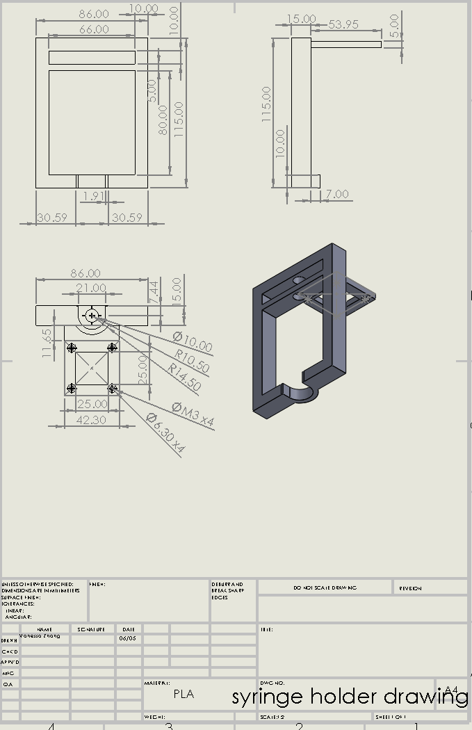 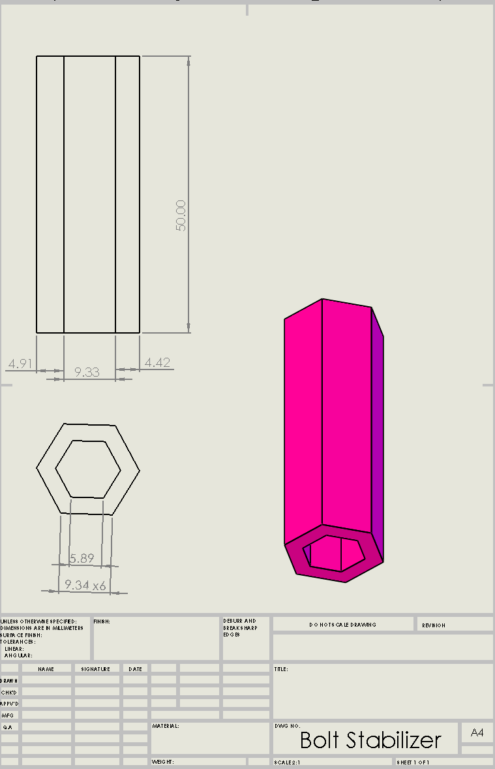

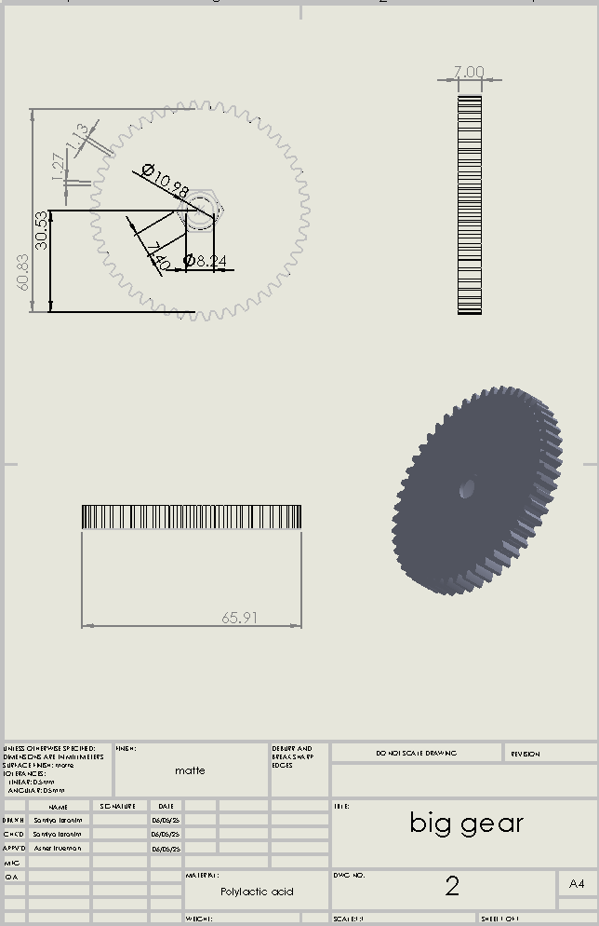

## Z-axis mechanism

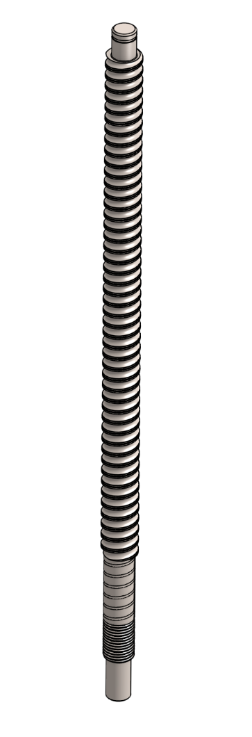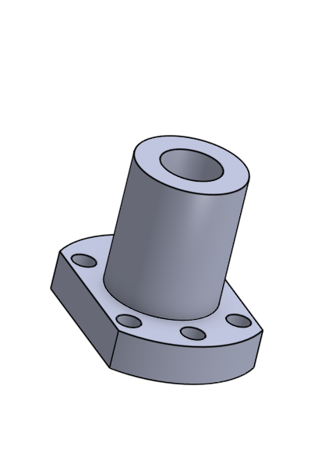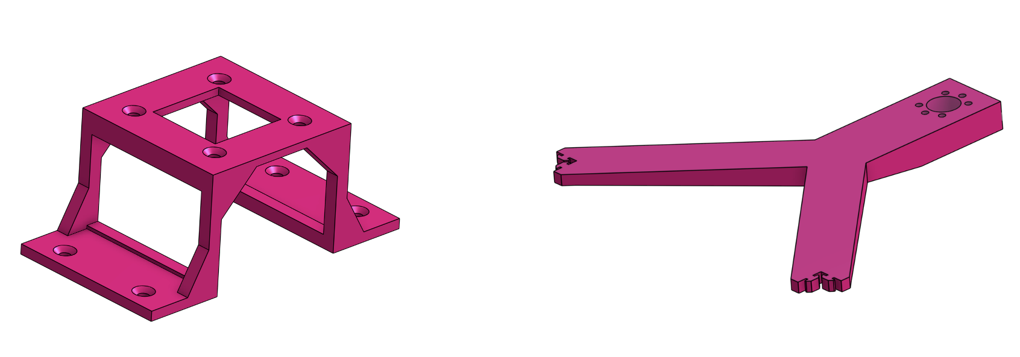

Main Frame

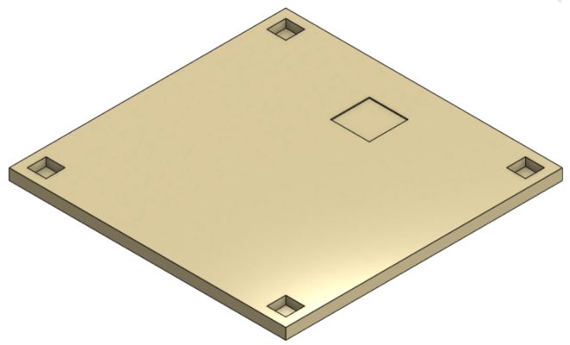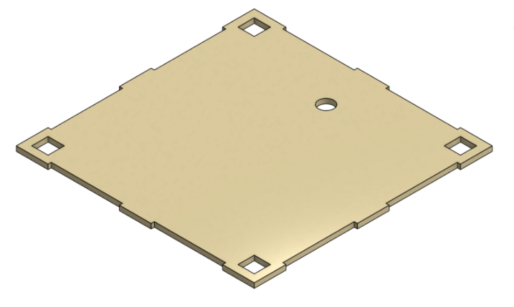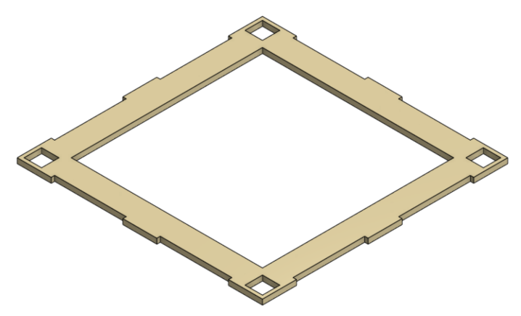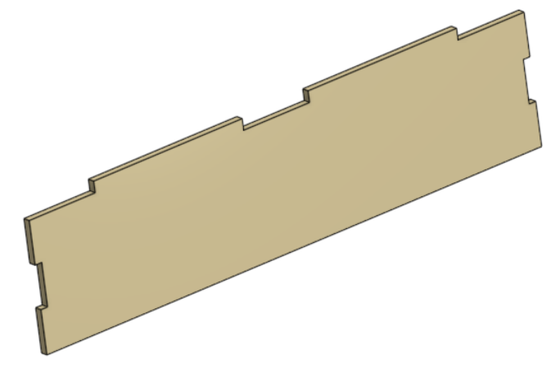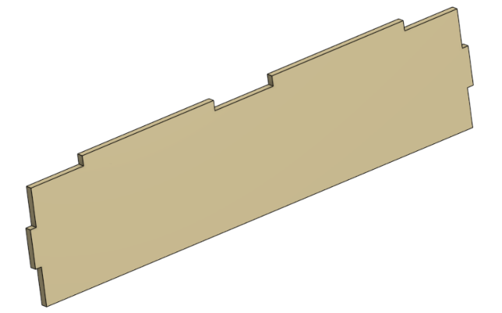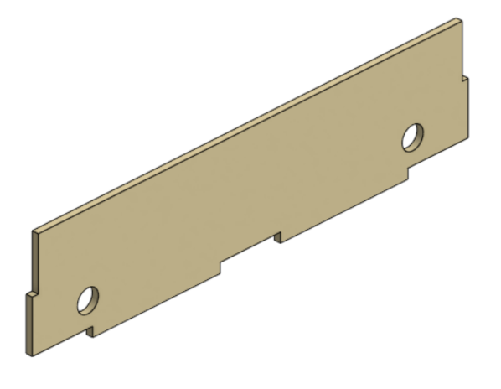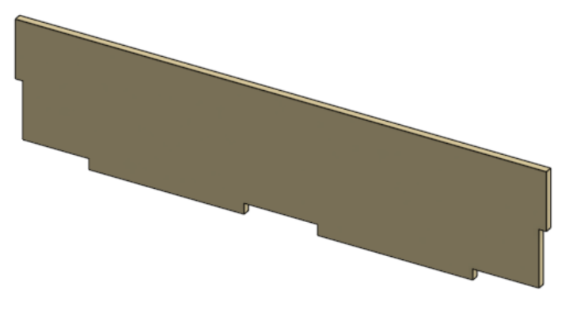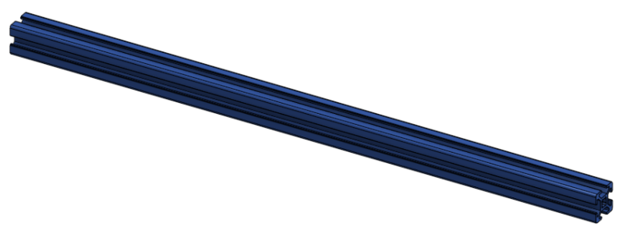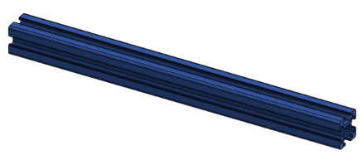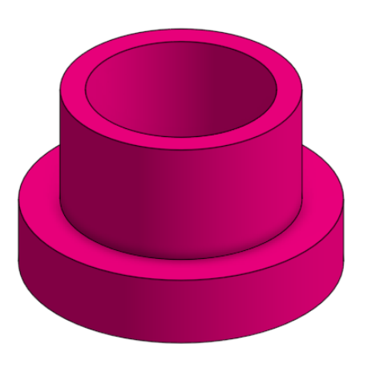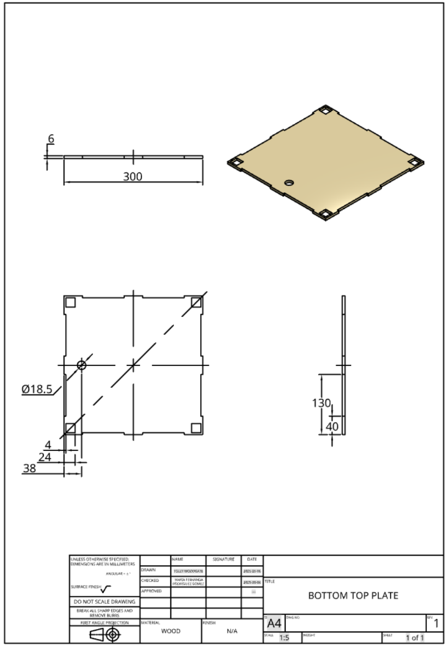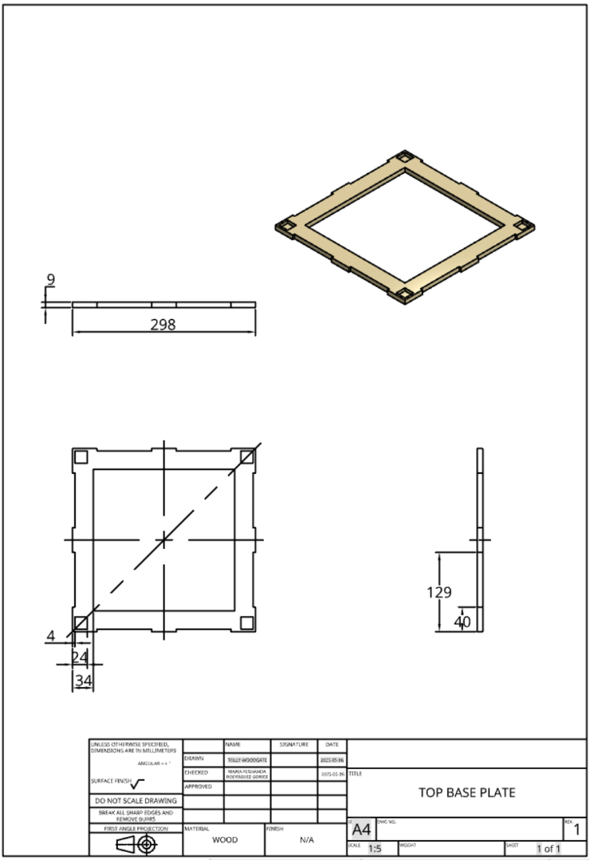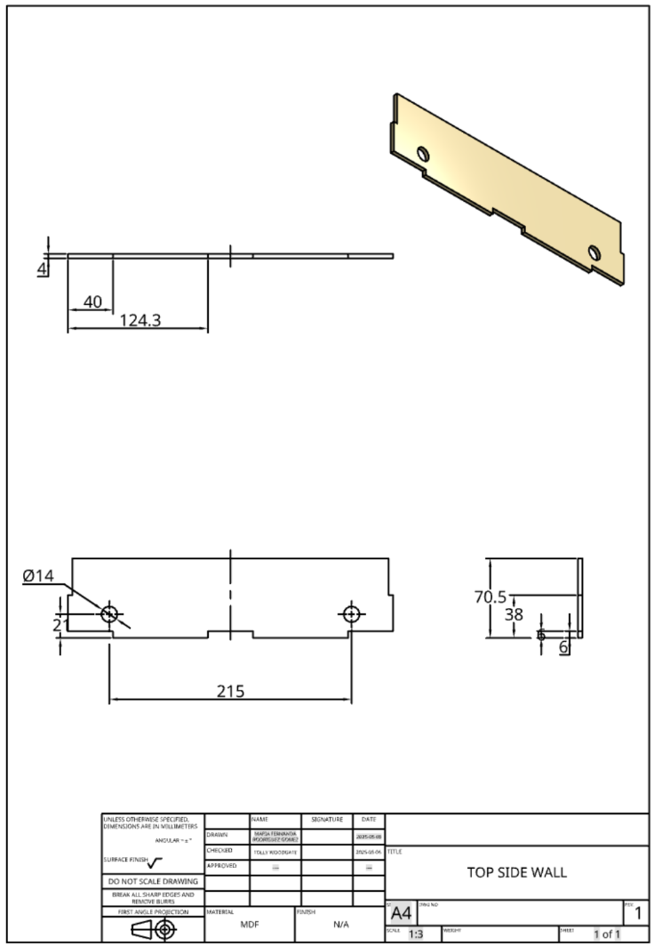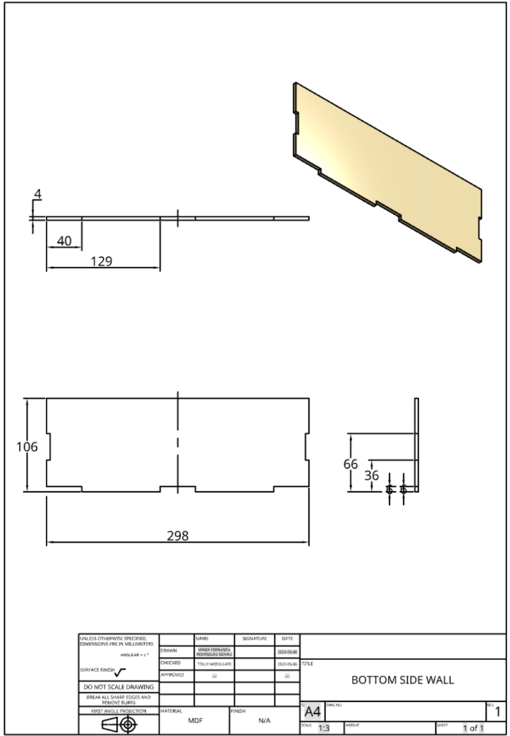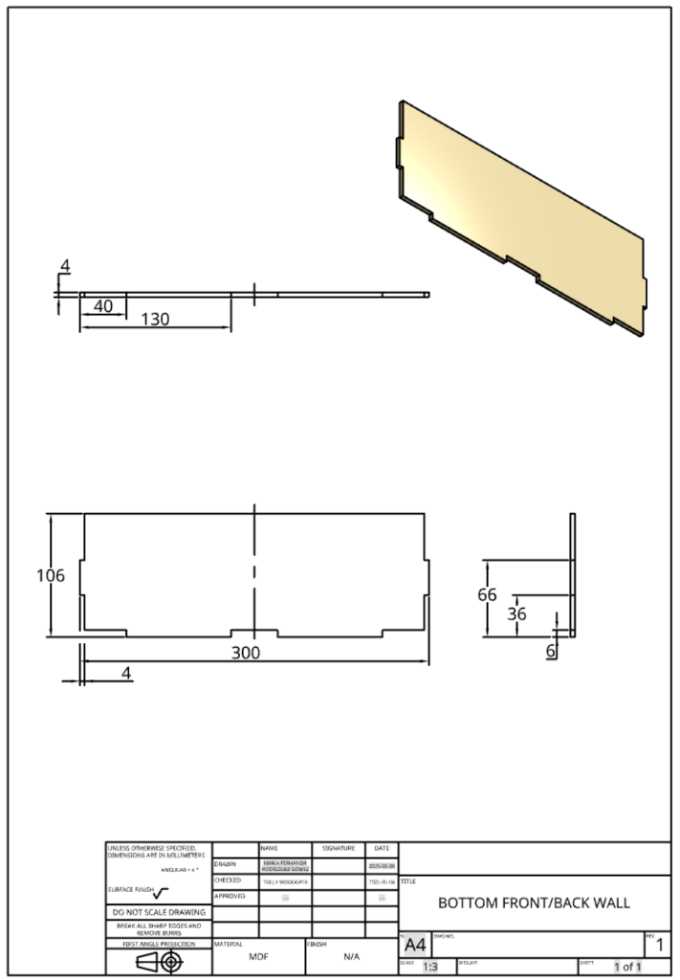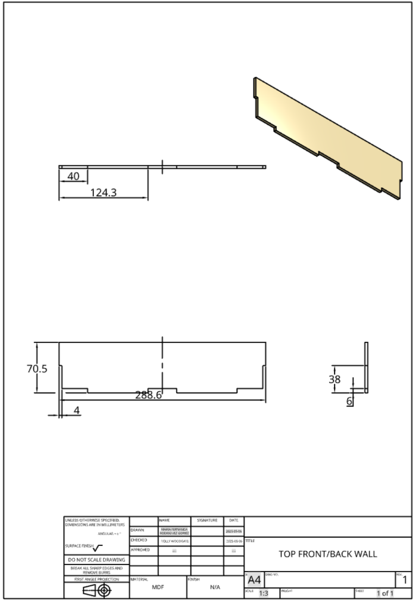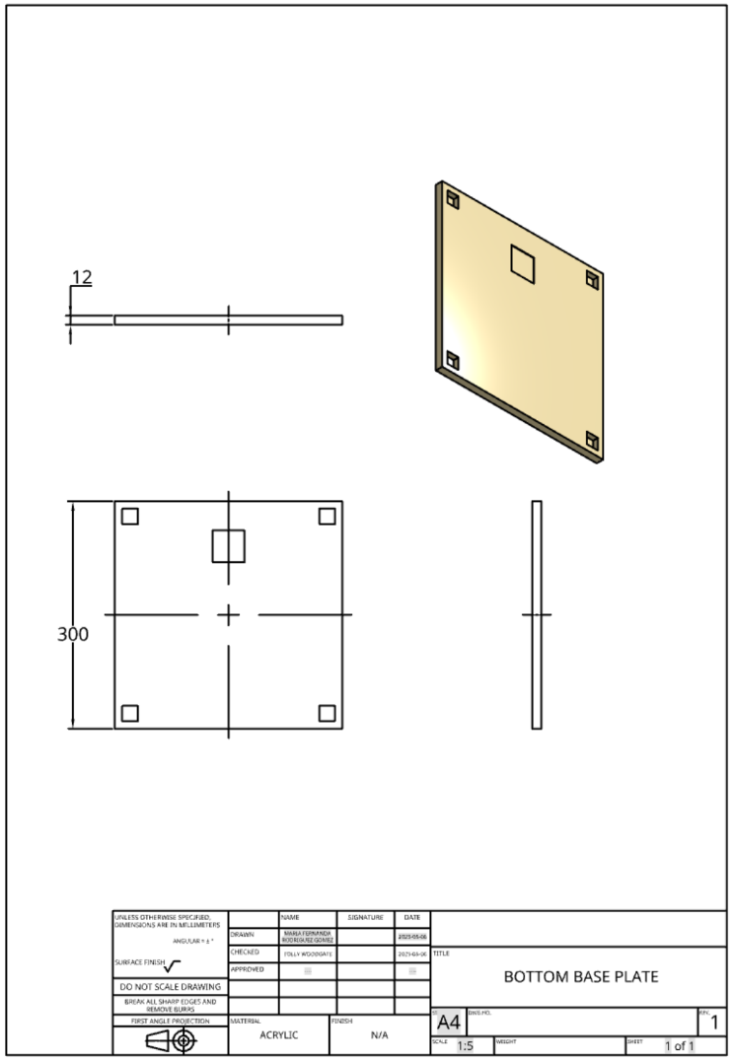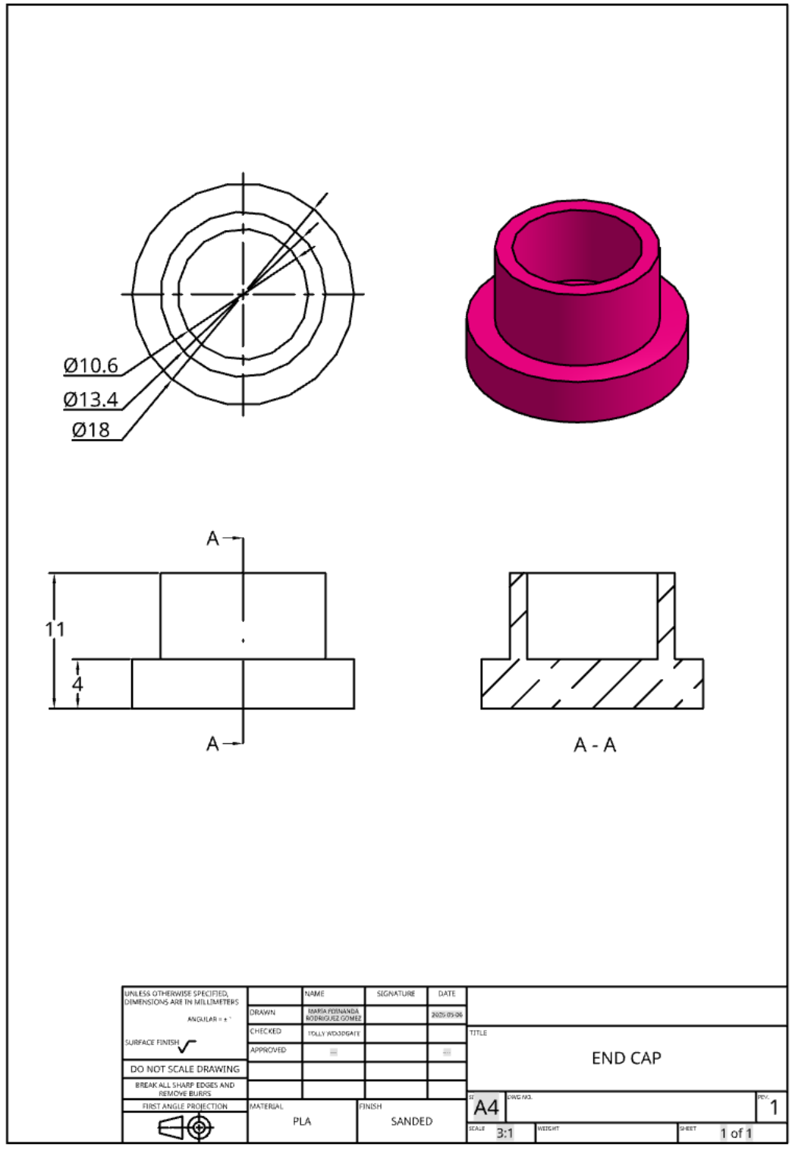

## X-Y Mechanism

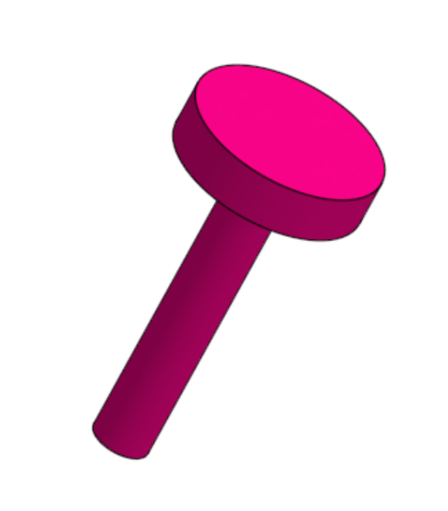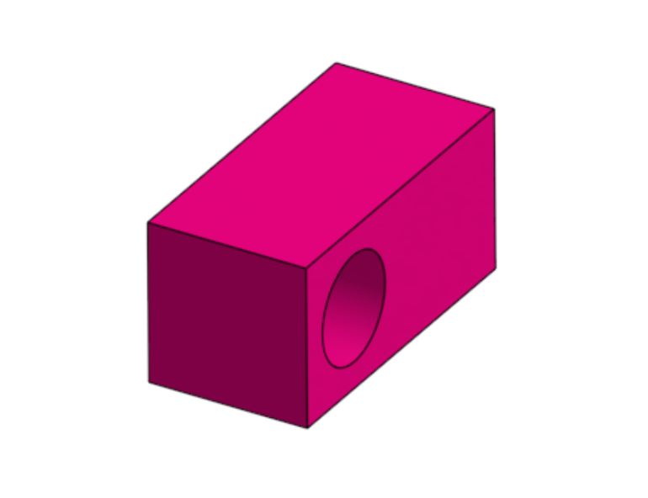

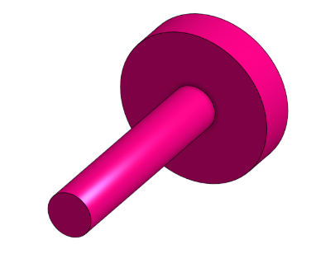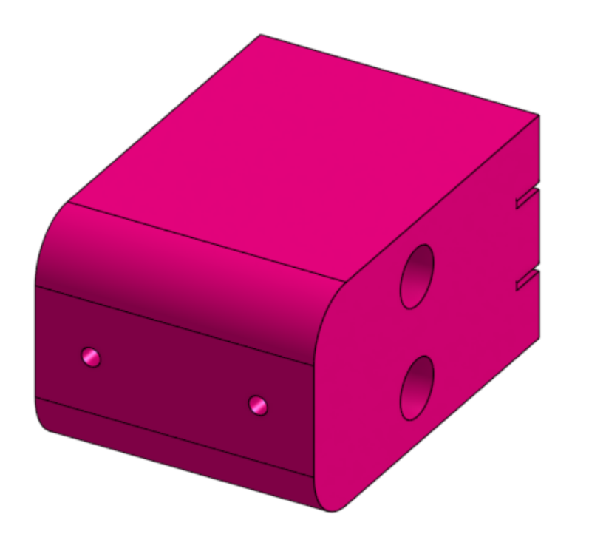

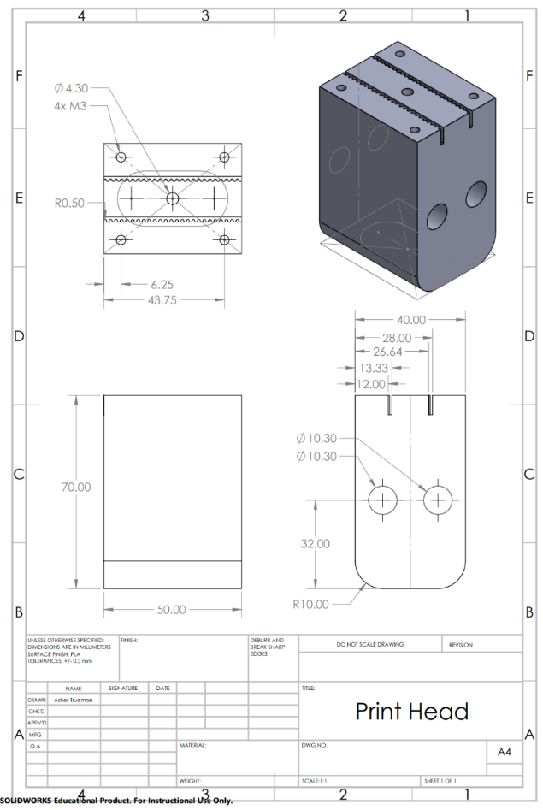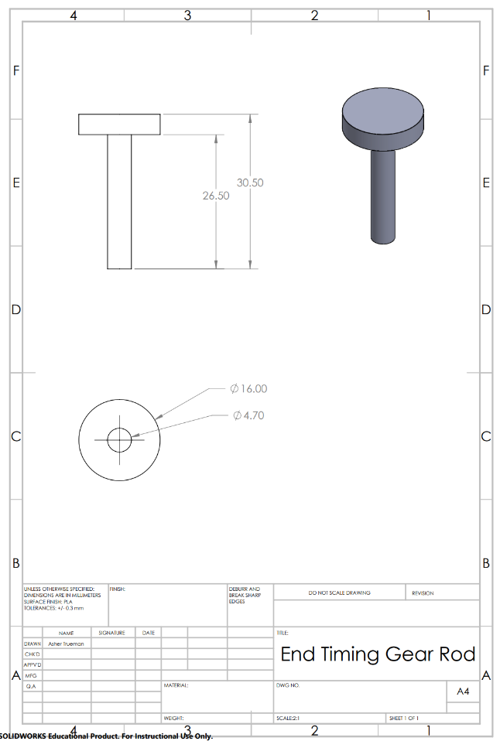

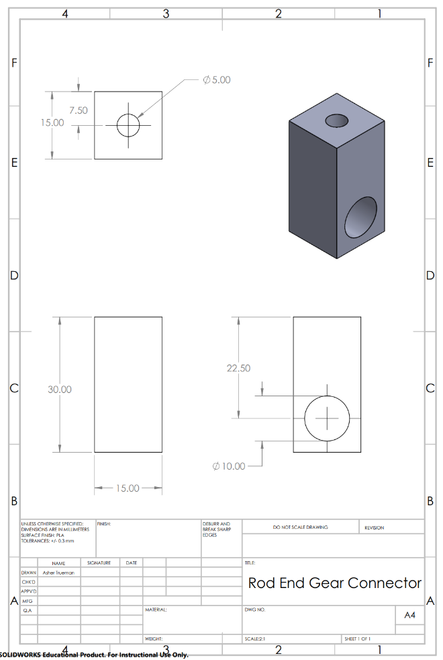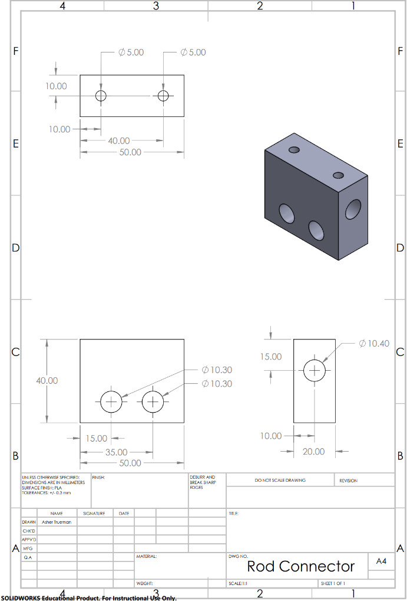

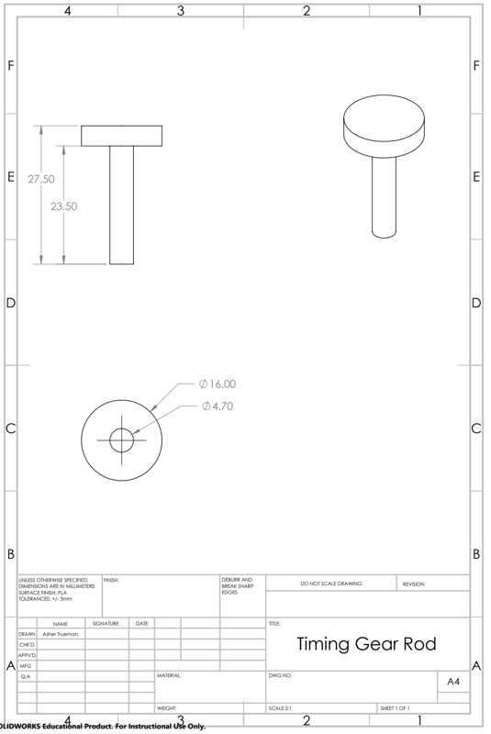

## Initial Code

#define EN 8 // Enable pin

// Direction pins

#define X_DIR 5

#define Y_DIR 6

#define Z_DIR 7

// #define E_DIR 0 // extruder motor (needs to fix pins)

// Step pins

#define X_STP 2

#define Y_STP 3

#define Z_STP 4

// #define E_STP 10 // pins need to be wired

int delayTime = 3000; // Microseconds between steps

int stps = 200; // Number of steps (1 rev = 200 steps) - change to 6400 for 32 microstepping

void step(boolean dir, byte dirPin, byte stepperPin, int steps) {

digitalWrite(dirPin, dir);

delay(100);

for (int i = 0; i < steps; i++) {

digitalWrite(stepperPin, HIGH);

delayMicroseconds(delayTime);

digitalWrite(stepperPin, LOW);

delayMicroseconds(delayTime);

}

}

void setup() {

pinMode(X_DIR, OUTPUT); pinMode(X_STP, OUTPUT);

pinMode(Y_DIR, OUTPUT); pinMode(Y_STP, OUTPUT);

pinMode(Z_DIR, OUTPUT); pinMode(Z_STP, OUTPUT);

pinMode(E_DIR, OUTPUT); pinMode(E_STP, OUTPUT);

pinMode(EN, OUTPUT);

digitalWrite(EN, LOW); // Enable all motors (LOW = enabled)

}

void loop() {

// All motors forward then back

step(false, X_DIR, X_STP, stps);

step(false, Z_DIR, Z_STP, stps);

step(false, Y_DIR, Y_STP, stps);

delay(1000);

step(true, X_DIR, X_STP, stps);

step(true, Y_DIR, Y_STP, stps);

step(true, Z_DIR, Z_STP, stps);

delay(1000);

}